**Question**

**Configure your system in such a way that when a user type and executes a describe command from anywhere of the system it must list all the files and folders of the user's current directory.**

**Ex:- $ describe**

**$ content1 content2**

**Content3 content 4**

**My Approach**

I solve this problem using the concept of Global Alias.

**Step 1 : Open Terminal**

**Step 2 : Become Root**

**Command = sudo -i**



**Step 3: Open FIle /etc/bash.bashrc**

**Command = nano /etc/bash.bashrc**

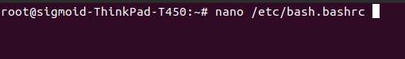

**Step 4: Add line**

**(alias describe=’ls’ )**

**in the file and save it.**

**￼**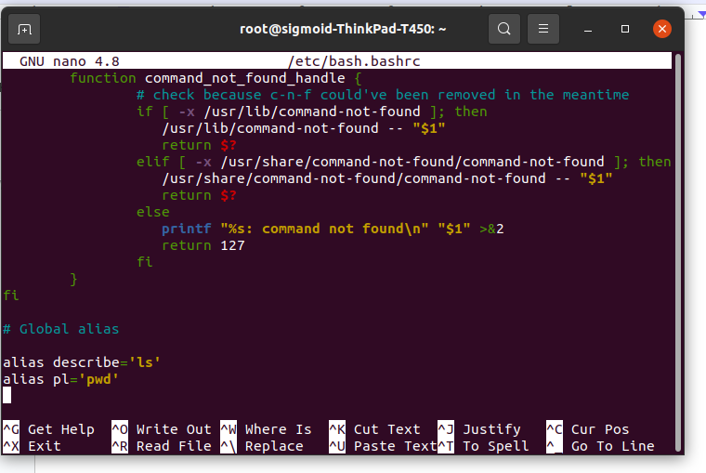

**￼￼**

Now Global alias is set go and run it anywhere It will list directory contents just like ls command.

**Example**

